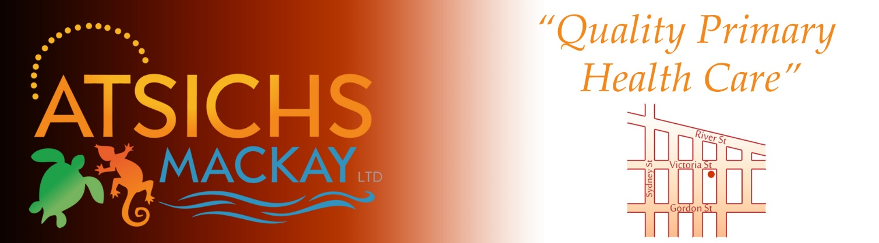
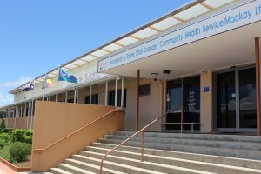

Position: GP Registrar under RVTS to Join a Dynamic Primary Health Care Team!
Aboriginal & Torres Strait Islander Health Services (ATSICHS) Mackay Ltd mission is to deliver a quality appropriate primary health care service to our regional community,
the Aboriginal and Torres Strait Islander people of the Mackay region that is tailored meet their health needs.
Our Values
Community Controlled and Led. Respect for Aboriginal and Torres Strait Islander people’s cultures.
Integrity and honesty. Support to and for our community. Recognition in our achievements.

Aboriginal and Torres Strait Islander Community Health Service Mackay LTD has an available position for a GP Registrar for Immediate Start who would like to pursue Fellowship under the Remote Vocational Training Scheme Pathway (RVTS). ATSICHS Mackay Ltd currently has a Supervisor for the RVTS which is a support program and pathway to fellowship. The pre-requisite for application to become an RVTS registrar would be having a contract with an Aboriginal Health Service prior to being accepted into the program.

ATSICHS Mackay Ltd meets accreditation requirements for training and has onsite training and support from supervisors. The health service has been involved in Registrar Training for 11 years. This is an opportunity for a Registrar with an interest in Indigenous Health to develop their special skills in this area of medicine in a
well-supported and friendly environment. Aboriginal and or Torres Strait Islander patients comprise over 90% of the health services population.
ATSICHS Mackay Ltd is NQSHS, ISO and APGAL accredited and uses electronic record and billing systems.

This is a great opportunity to contribute to Indigenous Health in this dynamic environment.

Please contact our HR Officer, Amanda Prewett on 07 4957 9416 or by emailing resumes to hr@atsichs.org.au to arrange an interview.

Strong Aboriginal & Torres Strait Islander communities managing their health to enjoy a long and quality life.

